SMART CAMPUS MANAGEMENT SYSTEM (SCMS)
- PART 2
Project Report - Assignment 2

COURSE: Object Oriented Programming using C++
COURSE CODE: CST 3301
TUTOR: Tawqeer ul Islam

STUDENT DETAILS:
NAME: ARYAN MAHAJAN
ROLL NO: 241103061
BRANCH: COMPUTER SCIENCE AND ENGINEERING
SEMESTER: 3RD
BATCH: 2024-2028

GROUP DETAILS:

Group Size: 4 Students

Student1: SIDDHARTH CHANDEL(241103013)
Student2: DANISHWAR SINGH JAMWAL(241103049)
Student3: ARYAN MAHAJAN (241103061)
Student4: BANSHIKA SHARMA(241103062)

https://github.com/AryanMahajan-tech/ASSIGNMENT-OBJECT-ORIENTED-PROGRAMMING-NO-01.git
GITHUB QR CODE



ATTENDANCE MANAGEMENT

System Features Implemented

AttendanceRecord Class

- Represents one student’s attendance entry
- Stores:
  - username → student identifier
  - date → attendance date
  - present → attendance status (present/absent)
Operator Overloading

- << operator → writes attendance data to file
- >> operator → reads attendance data from file
This simplifies file I/O and makes the code readable and reusable.

Daily Attendance File Handling

Each file contains records for one specific day

Module F manages student attendance using object-oriented programming and file handling. Attendance records are stored in daily files with operator overloading for efficient data I/O. File pointers are controlled using seekg() and seekp() to demonstrate random access. All attendance activities are logged for accountability.

Project Structure

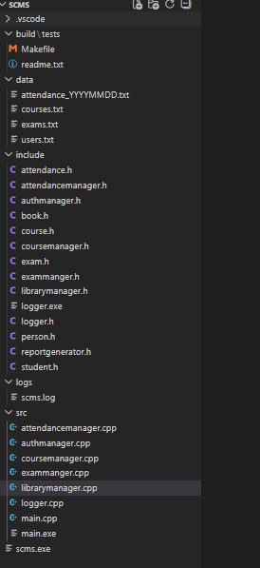

UML Class Diagrams

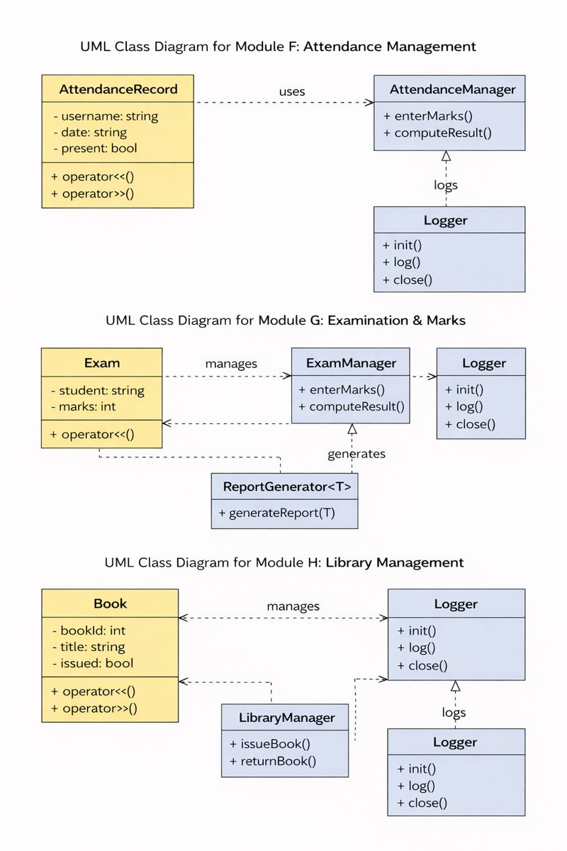

Modules Explanation

Module F: ATTENDANCE MANAGEMENT

:
    - Created a well-organized directory structure following software engineering best practices
    - Implemented Makefile for automated compilation and build process
    - Developed a user-friendly console menu system using cin/cout
    - Added comprehensive code documentation using comments
    - Followed modular programming approach for better maintainability

Code Structure:

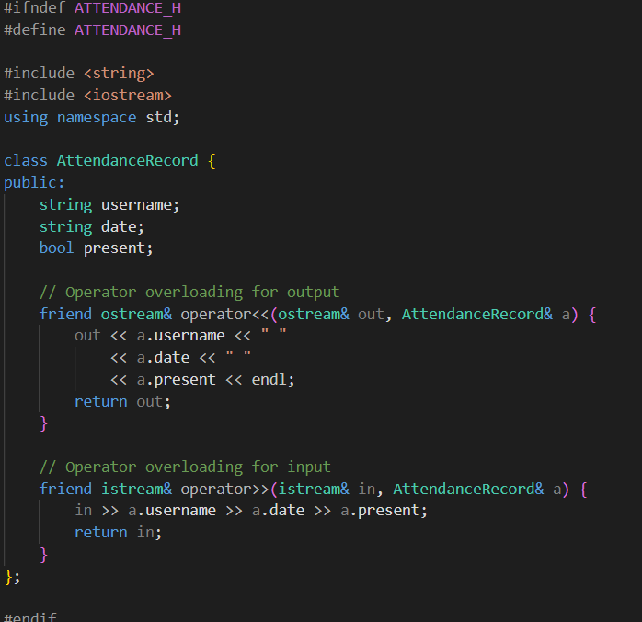

Attendance.h
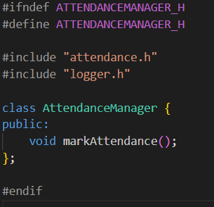

Attendancemanager.h

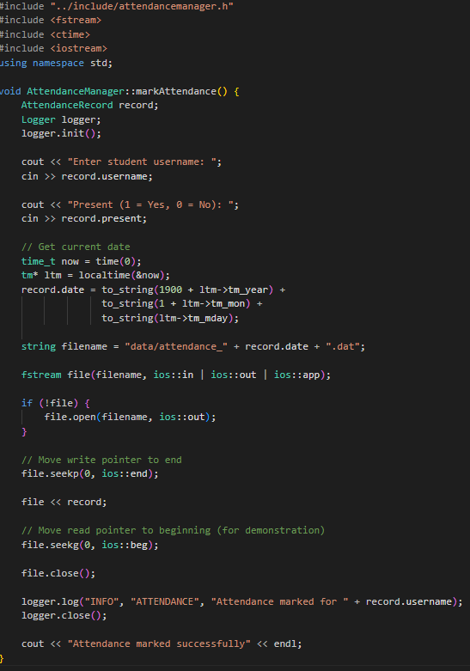
Attendancemanager.cpp

Module G: Examination and Marks Module

We designed and implemented a Student Course Management System (SCMS) using object-oriented programming in C++.
The system was divided into multiple modules such as authentication, courses, attendance, examinations, and library management.
Each module uses classes, file handling, operator overloading, templates, and exception handling to store and process data.
A centralized Logger was implemented to record all system activities, making the project structured, modular, and exam-ready.

Program Inputs

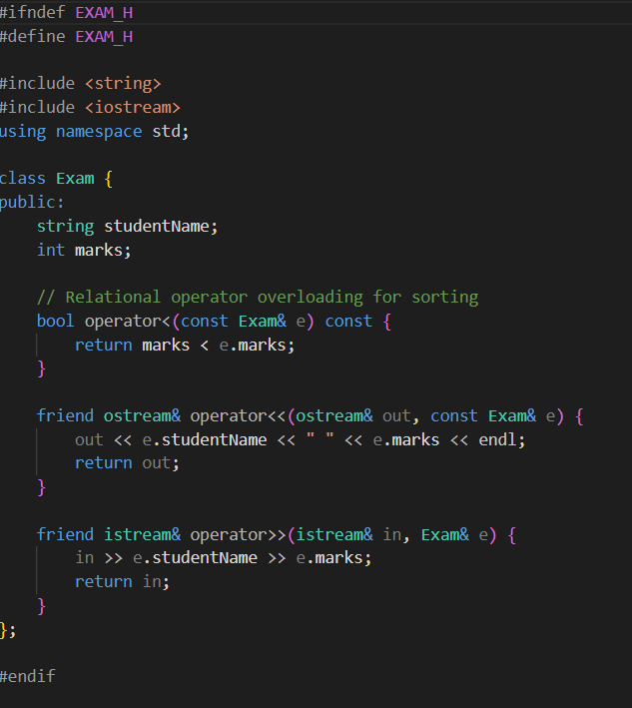

Exam.h

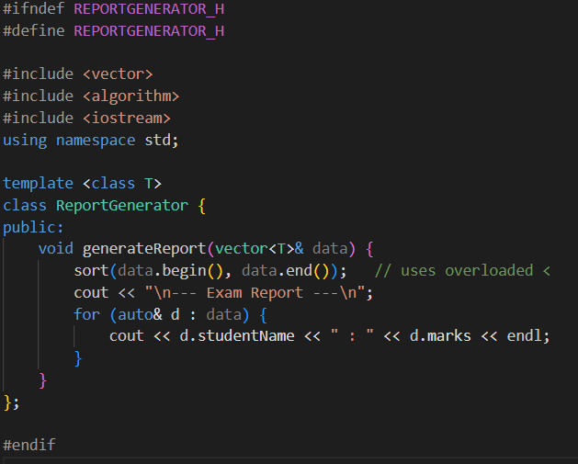

Reportgenerator.h

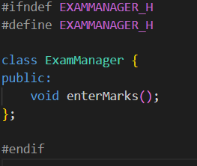

Exammanger.h
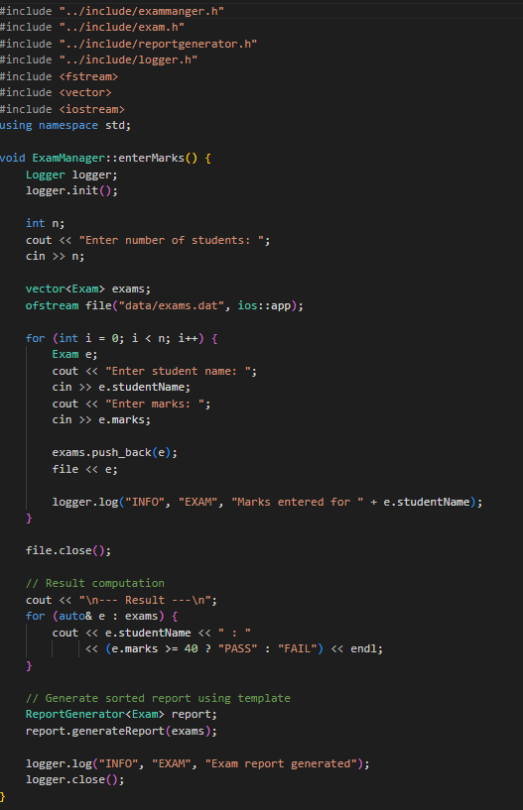
Exammanger.cpp

Module H: Library Management

Module H (Library Management) handles the management of books by allowing issuing and returning operations.

It uses a Book class to store book details and a LibraryManager class to control library activities.

The module uses file handling to store book records and transaction history with proper exception handling for errors.

All library operations are recorded using the Logger to ensure tracking and accountability.

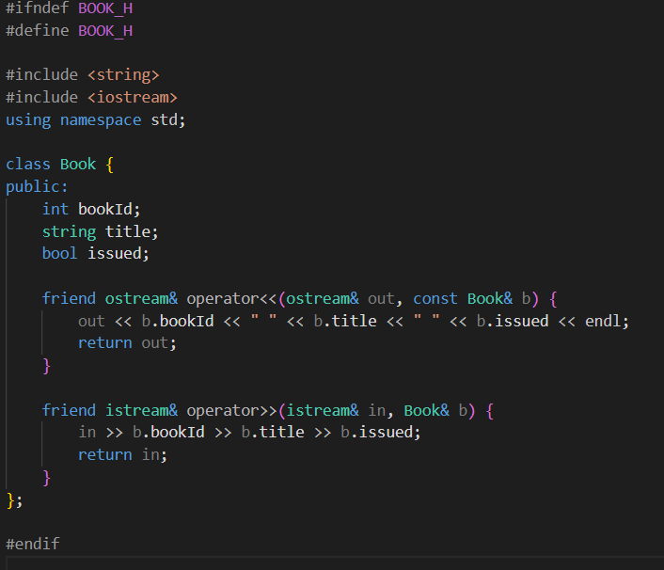

Book.h

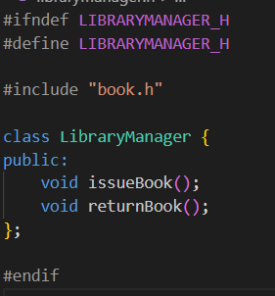

Librarymanager.h

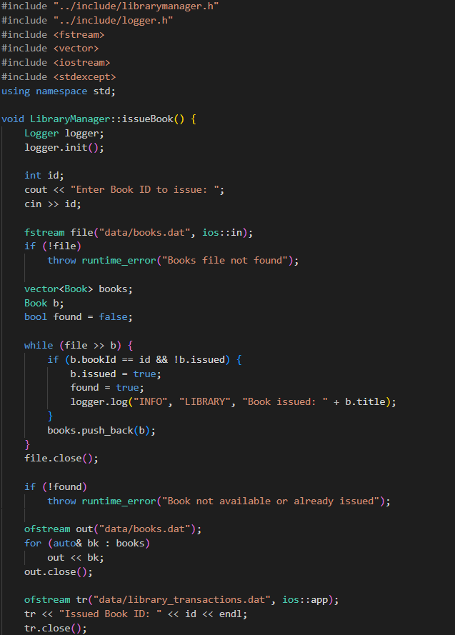

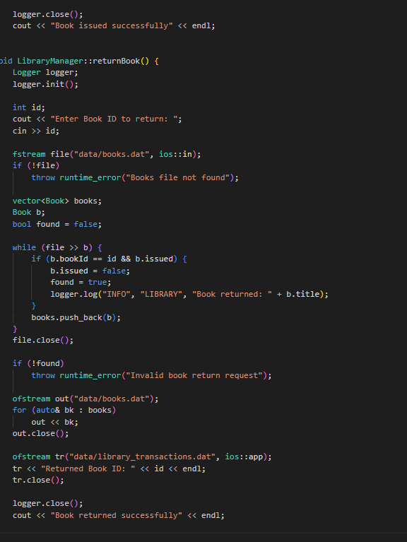

Exammanager.cpp

Output of Running Program

      - --- SCMS MENU ---
      - 1. Register
      - 2. Login
      - 3. Attendance
      - 4. Exams
      - 5. Library
      - 6. Exit
      - Enter choice: 1
      - Enter username: Aryan
      - Enter password: 2305
      - User registered successfully.

      - --- SCMS MENU ---
      - Enter choice: 2
      - Enter username: Aryan
      - Enter password: 2305
      - Login successful.

      - --- SCMS MENU ---
      - Enter choice: 3
      - Enter student username: Aryan
      - Mark Present (1) or Absent (0): 1
      - Attendance marked successfully.

      - --- SCMS MENU ---
      - Enter choice: 4
      - Enter student username: Aryan
      - Enter marks: 85
      - Result: PASS

      - --- SCMS MENU ---
      - Enter choice: 5
      - --- LIBRARY MENU ---
      - 1. Issue Book
      - 2. Return Book
      - Enter choice: 1
      - Enter Book ID: 101
      - Book issued successfully.

      - --- SCMS MENU ---
      - Enter choice: 6
      - Exiting...

LOGGER OUTPUT FILE

[INFO] User registered: sid
[INFO] User logged in: Aryan
[INFO] Attendance marked for Aryan
[INFO] Exam marks entered for Aryan
[INFO] Book issued: ID 101

Conclusion

- Extended SCMS with Attendance, Examination, and Library management modules.
- Used advanced C++ features like templates, operator overloading, and exceptions.
- Implemented persistent storage through multiple data and log files.
- Improved system completeness, making SCMS closer to a real-world application.

